MIDLANDS REPERTORY THEATER CAMP
Sponsorships
The James M. Hinton Foundation announces the launching of the Midlands Repertory Theater. The Theater will be held June 17-21 with an arts day camp. The week-long camp will culminate on Saturday, June 22 with a presentation of Ego Tripping & Churchin. The opportunity for your students are:

- Vocalist | - Dancer | - Drama
- String Instruments | - Trumpet | - Trombone

Please join us in supporting the development and growth of our students in the Midlands by becoming a sponsor of the Midlands Repertory Theater Summer Camp, 2019. Sponsorship options are:

Gold Sponsorship ($500.00)
Name printed on all programs for the 2019-2020 cycle. Business logo or name showcased on a page of its own on large screen (via PowerPoint) during the performance. Name read verbally as sponsor during the Summer Camp Showcase.

Silver Sponsorship ($300.00)
Name printed on all programs for the 2019-2020 cycle. Business logo or name showcased on a page of its own on large screen (via PowerPoint) during the performance.

Bronze Sponsorship ($200.00)
Business logo or name showcased on a page of its own on large screen (via PowerPoint) during the performance.

Patron ($100.00)
Business logo or name showcase on a page with other patrons during the performance.

Parental Congratulations ($50.00)
Child’s picture and a congratulatory message showcased on a page of its own on a large screen (via PowerPoint) during the performance.

Parental Recognition ($25)
Child’s name showcased with congratulations from you on a page with other parental recognitions.

The James M. Hinton Foundation Presents
MIDLAND’S REPERTORY THEATER (MRT) – 2019
MRT is a cutting-edge and exemplary summer camp experience Featuring dance, drama, choir, instrumental music, or voice lessons
Students (ages 5 through 18) are invited to participate in the week-long camp June 17 – 21, 9:00 a.m. – 5:00 p.m.
The camp (which is free of charge) will culminate in a musical theater showcase Sat., June 22, 12:00 Noon, Second Calvary Baptist Church
Click on the link below to register.
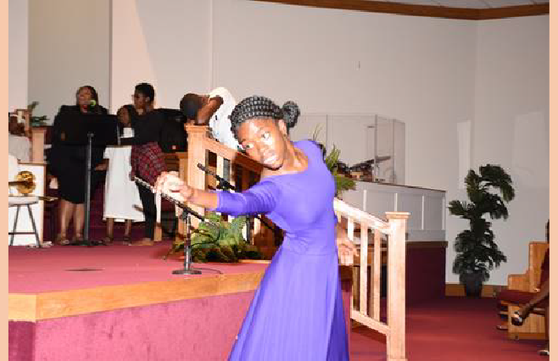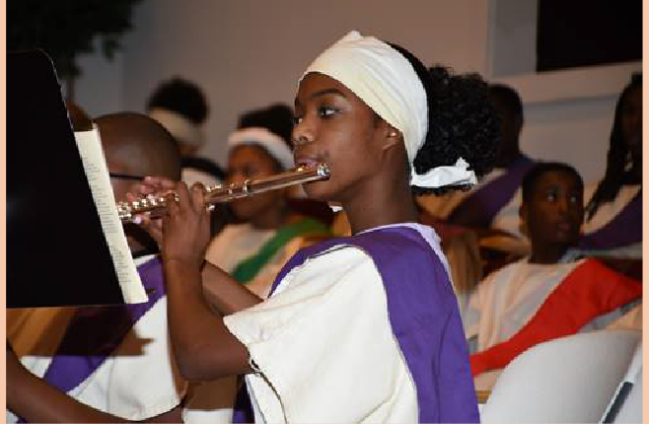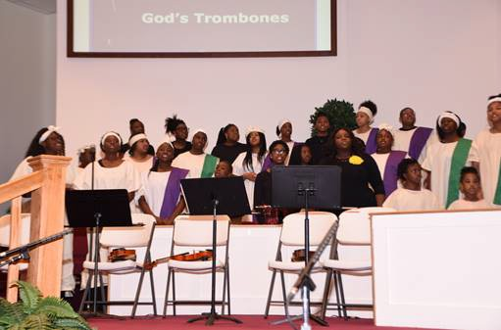Registration: http://www.jmhintonfoundation.org/mrt-registration/
PICTURES FROM
MIDLAND’S REPERTORY THEATER CAMP – 2018
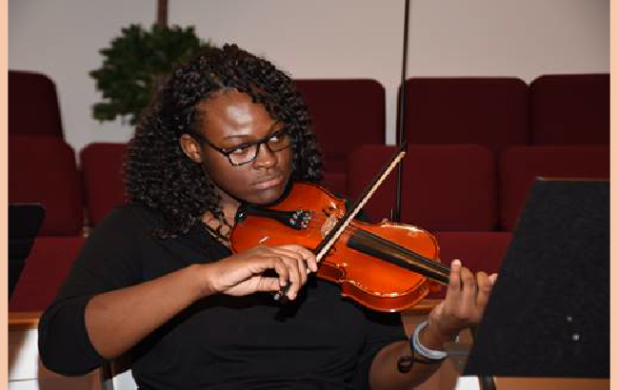
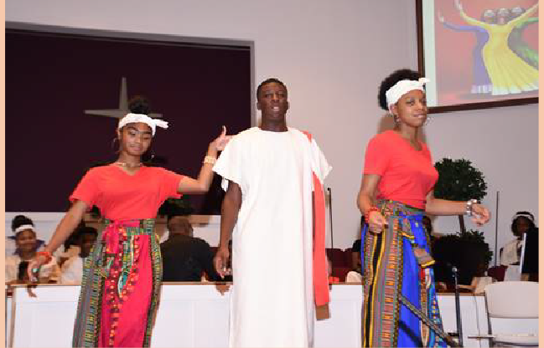
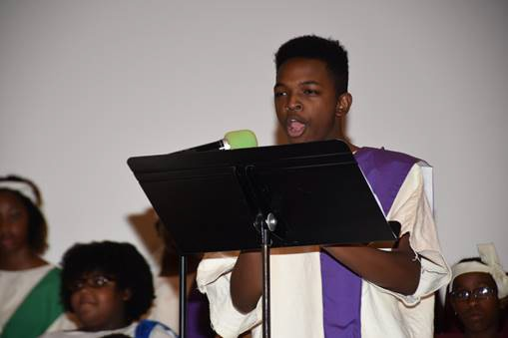

Midlands Repertory Theater Summer Camp
SPONSORSHIP APPLICATION

Sponsor’s name or organization:

Sponsor’s mailing address:

Sponsor’s email address:

Sponsor’s Phone Number

Level of sponsorship (Please check the level of your sponsorship in Section I, provide the message you want to convey in Section II, and attach a picture of logo.

SECTION I: Level of Sponsorship.
Gold Sponsorship ($500.00)
Silver Sponsorship ($300.00)
Bronze Sponsorship ($200.00)
Patron ($100.00)
Parental Congratulations ($50.00)
Parental Recognition ($25)

SECTION II: Sponsorship message

GOLD, SILVER, BRONZE, PARENTAL CONGRATULATIONS
Please provide the message below that you want showcase on the Screen for Gold, Silver, Bronze, Parental Congratulations and attach a logo or picture:

PATRON
Patron (Provide your name)

congratulates the Midland’s Repertory Theater in its presentation of James Weldon Johnson’s God’s Trombone.

PARENTAL RECOGNITION
Parental Recognition (Please provide your name and the name of the child that you want to recognize)

congratulates on Her/His performance with the Repertory Theater in its presentation of James Weldon Johnson’s God’s Trombone.

Make all checks payable to the James M. Hinton Foundation.
1110 Mason Road Columbia, SC 29203

